Written Comprehension Questions By Level
These are questions stems you can use at home to help your child practice writing their answers to comprehension questions about a book. You can also use these when your child answers questions orally.
Level F, G, H
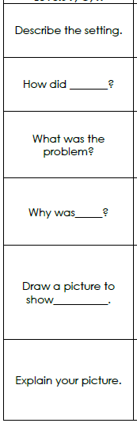 | 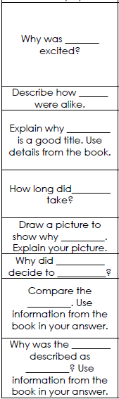 | 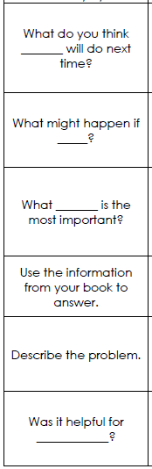 | 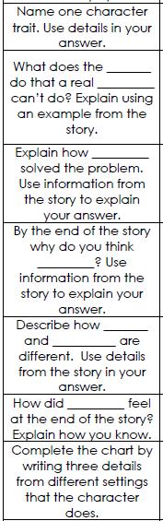

Levels I, J, K
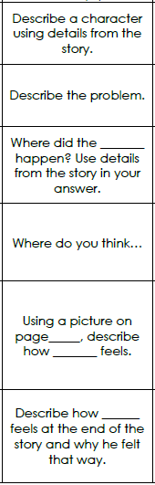 | 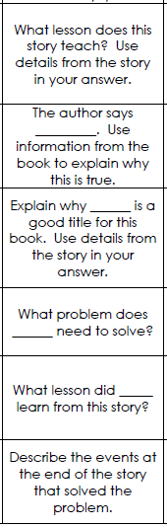 | 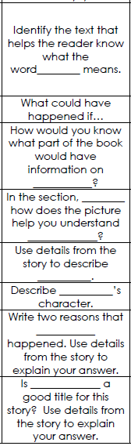 | 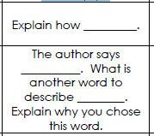

Levels L, M, N
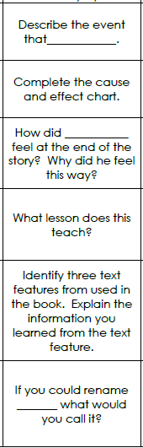 | 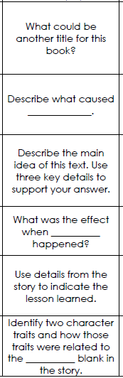 | 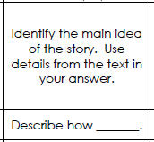

Levels O, P, Q
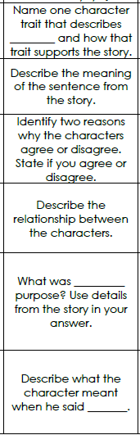 | 